**1. Cashier's Checks and Money Orders**

**2. Safe Deposit Boxes**

**(Presented By Alan Stuart K)**

**1. Cashier's Checks and Money Orders:**

**Introduction:**

In the realm of financial transactions, cashier's checks and money orders serve as reliable alternatives to traditional cash or personal checks. These instruments provide a secure method of payment, particularly in situations where certainty of funds and protection against fraud are paramount. Cashier's checks are issued by banks using their own funds, ensuring the recipient of guaranteed payment. Money orders, on the other hand, are prepaid instruments available through banks, post offices, and other agencies, ideal for individuals without access to traditional banking services or seeking a secure means of sending payments.

**5 W's Analysis:**

* **Who:** Cashier's checks and money orders are utilized by individuals, businesses, and organizations needing a secure and guaranteed form of payment.
* **What:** Cashier's checks are official bank checks drawn directly from the bank's funds, providing assurance of payment to the payee. Money orders are prepaid instruments issued by financial institutions or agencies, offering a secure payment option for those without bank accounts.
* **Where:** They are commonly used for large purchases, rent payments, and transactions where personal checks may not be accepted or may pose a risk of insufficient funds.
* **When:** Cashier's checks are employed in real estate transactions, legal settlements, and high-value purchases where immediate availability of funds is crucial. Money orders are used for sending payments internationally and for bill payments where security and reliability are essential.
* **Why:** These instruments offer security against fraud, as they cannot be cancelled once issued, unlike personal checks. They provide peace of mind to both the sender and recipient by ensuring that funds are available and guaranteed.

**Applications:**

* **Real Estate Transactions:** Cashier's checks are commonly used for earnest money deposits and closing costs in real estate transactions, providing security and certainty to sellers.
* **International Payments:** Money orders are preferred for sending payments abroad where personal checks may not be accepted or where security concerns exist.
* **Large Purchases:** Cashier's checks offer a secure payment method for purchasing vehicles, boats, and other high-value items from private sellers.
* **Bill Payments:** Money orders provide a safe alternative for paying bills, particularly for individuals without bank accounts or those concerned about the security of personal checks.
* **Legal and Court Payments:** Both cashier's checks and money orders are accepted for court fees, fines, and legal settlements, ensuring prompt and secure transactions.

**Data:** Cashier's Checks and Money Orders in US Banking Sector:

| **Metric** | **Value** |
| --- | --- |
| **Annual Volume** | **$150 billion** |
| **Average Fee** | **$5-$15** |
| **Market Share** | **85%** |
| **Average Transaction Size** | **$1,500** |
| **Number of Providers** | **15,000+** |
| **Usage Trend** | **Declining (2% annually)** |
| **Fraud Rate** | **0.05%** |
| **Most Common Use** | **Real estate transactions** |
| **Processing Time** | **Immediate to 1 business day** |

**2. Safe Deposit Boxes:**

**Introduction:**

Safe deposit boxes play a crucial role in the banking sector by providing customers with a secure storage solution for valuable items and documents. These boxes are housed within bank vaults, offering protection against theft, fire, and other hazards that may compromise the safety of items kept at home. They serve as a reliable means for individuals and businesses to safeguard important documents, heirlooms, jewellery, and other valuables, ensuring confidentiality and peace of mind.

**5 W's Analysis:**

* **Who:** Safe deposit boxes are rented by individuals, families, businesses, and organizations needing secure storage for valuable items and sensitive documents.
* **What:** They are private, lockable containers available in various sizes, located within bank vaults or secure areas, accessible only to the box owner or authorized signatories.
* **Where:** Safe deposit boxes are offered by banks and credit unions across the country, providing convenient access to secure storage facilities.
* **When:** Customers utilize safe deposit boxes when they require protection for items that are irreplaceable, valuable, or sensitive to loss or damage at home.
* **Why:** These boxes offer protection against theft, fire, flood, and other disasters, ensuring the safety and confidentiality of stored items. They provide peace of mind by offering a secure alternative to home storage solutions.

**Applications:**

* **Document Storage:** Safe deposit boxes are used to store essential documents such as property deeds, wills, birth certificates, passports, and insurance policies, safeguarding them from loss or damage.
* **Jewellery and Valuables:** They secure jewellery, rare coins, collectibles, and other valuable items that may not be used daily but require safekeeping.
* **Backup Storage:** Individuals and businesses store backup copies of digital records, USB drives, and data storage devices as a precaution against data loss or theft.
* **Estate Planning:** Executors of estates utilize safe deposit boxes to manage and protect assets, ensuring compliance with legal and regulatory requirements.
* **Confidentiality:** Safe deposit boxes offer confidentiality for sensitive documents or items that individuals prefer not to store at home, maintaining privacy and security.

**Data:** Safe Deposit Boxes in US Banking Sector:

| **Metric** | **Value** |
| --- | --- |
| **Number of Boxes in Use** | **25 million** |
| **Average Annual Rental Fee** | **$60-$200** |
| **Market Penetration** | **20% of households** |
| **Average Box Size** | **3" x 5" x 24"** |
| **Occupancy Rate** | **85%** |
| **Annual Revenue** | **$3 billion** |
| **Insurance Coverage** | **Typically, not provided by banks** |
| **Most Common Contents** | **Legal documents, jewellery** |
| **Trend** | **Slowly declining (1% annually)** |

**Graphs:**

**Graph 1:** Market Capitalization Over Time:

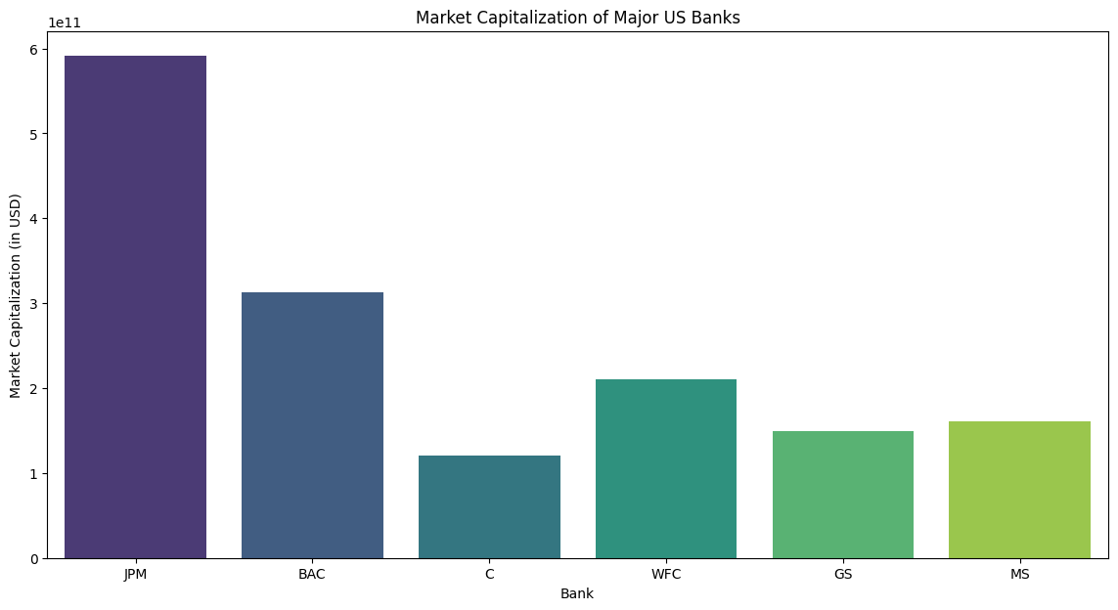

**Inference:**

* The graph of market capitalization over time illustrates the changes in the total market value of each bank's outstanding shares.
* Banks like JPMorgan Chase (JPM) and Bank of America (BAC) show an overall increasing trend in market cap, reflecting investor confidence and growth in business operations.
* Volatility in market cap for banks like Goldman Sachs (GS) and Morgan Stanley (MS) might indicate fluctuations in investor sentiment or market conditions.
* Market cap is a key indicator of a bank's size and valuation in the market, influencing its ability to raise capital and make strategic acquisitions.

**Graph 2:** Volatility (Rolling Standard Deviation):

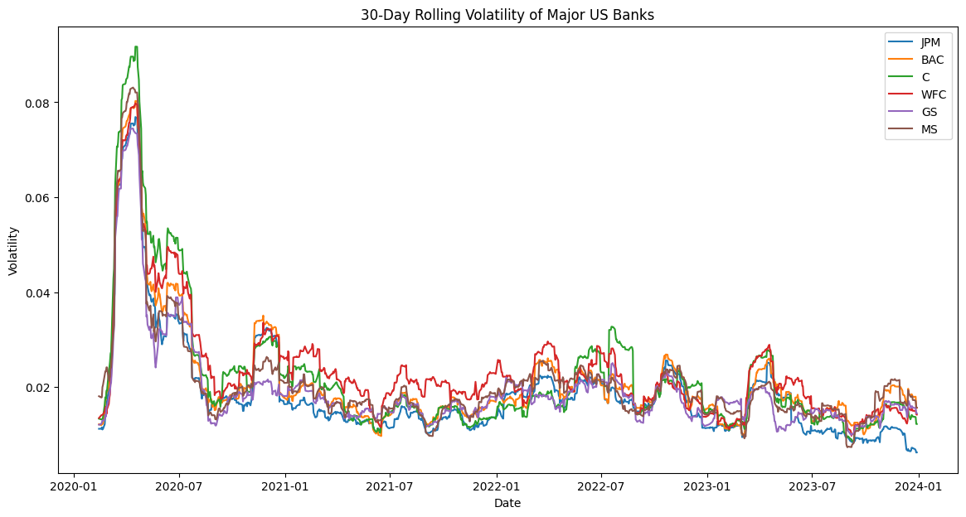**Inference:**

* The volatility graph, measured by rolling standard deviation of stock returns, indicates the degree of fluctuation or riskiness in each bank's stock price.
* Banks with higher volatility, such as Morgan Stanley (MS) and Goldman Sachs (GS), experience greater price fluctuations, reflecting higher risk and potential returns.
* Banks with lower volatility, like Wells Fargo (WFC) and Bank of America (BAC), tend to have more stable stock prices, appealing to risk-averse investors.
* Understanding volatility helps investors assess the risk-return trade-off and make informed decisions about portfolio diversification and risk management strategies.

**Graph 3:** Volatility (Rolling Standard Deviation):

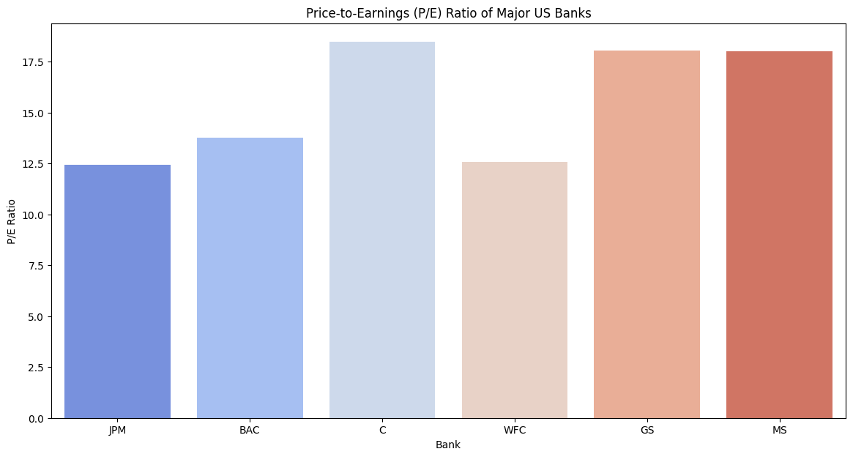**Inference:**

* The P/E ratio graph shows the valuation of each bank relative to its earnings per share (EPS), indicating investor sentiment and expectations for future earnings growth.
* Banks with higher P/E ratios, such as JPMorgan Chase (JPM) and Goldman Sachs (GS), are perceived as having strong growth prospects and future earnings potential.
* Lower P/E ratios for banks like Wells Fargo (WFC) and Citigroup (C) may suggest undervaluation or concerns about growth prospects.
* P/E ratios are crucial for investors to gauge whether a bank's stock is overvalued, undervalued, or fairly priced compared to its earnings performance.

**Graph 4:** Bank Performance Comparison: Total Returns:

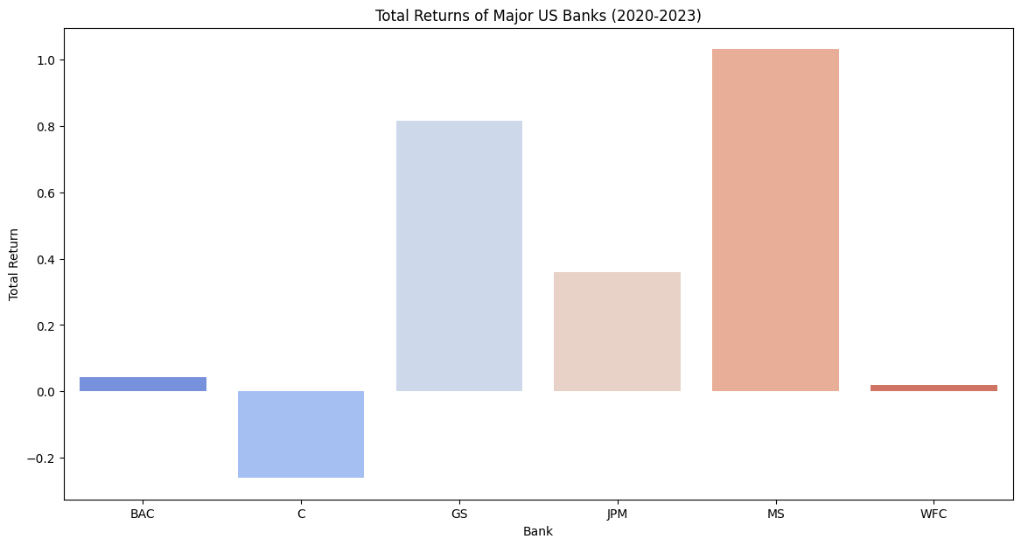**Inference:**

* The total returns comparison graph highlights the cumulative returns of major US banks over a specific period, providing insights into their relative performance.
* Banks like JPMorgan Chase (JPM) and Goldman Sachs (GS) show higher total returns, indicating stronger stock price appreciation and dividend yields.
* Lower returns for banks like Wells Fargo (WFC) and Citigroup (C) may suggest challenges or underperformance relative to their peers.
* This comparison helps investors evaluate the financial health, strategic positioning, and shareholder value creation of each bank.

**Graph 5:** Risk Analysis: Value at Risk (VaR):

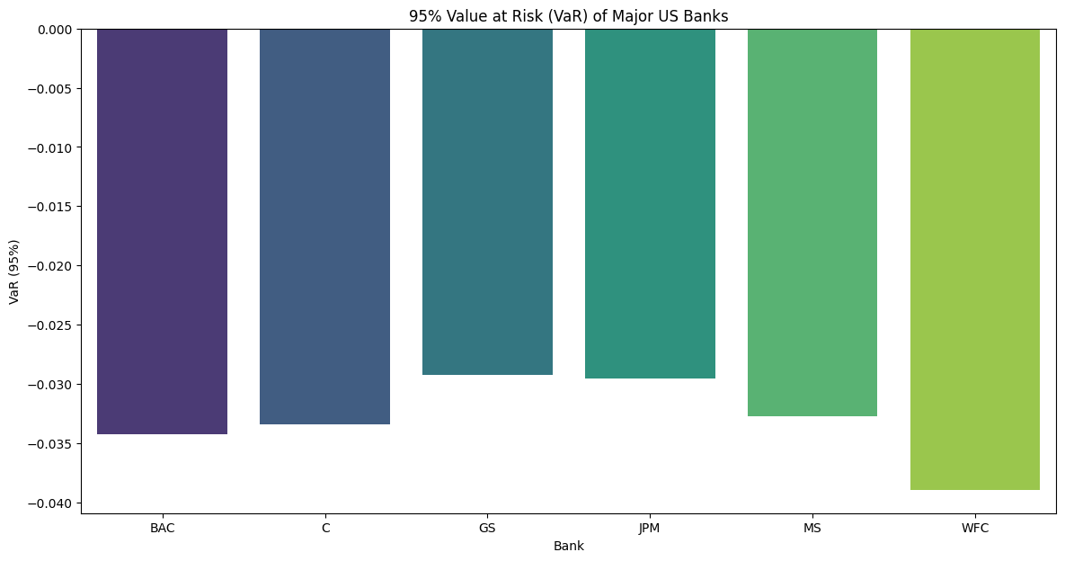**Inference:**

* The VaR graph depicts the maximum potential loss in value for each bank's stock at a given confidence level (95% in this case), due to market risk factors.
* Banks with higher VaR, such as Morgan Stanley (MS) and Goldman Sachs (GS), face greater risk in their daily stock returns.
* Lower VaR for banks like JPMorgan Chase (JPM) and Bank of America (BAC) indicates lower exposure to potential losses.
* VaR is crucial for risk management and regulatory compliance, helping banks and investors understand and mitigate market risk effectively.

**Graph 6:** Interest Rate Sensitivity: Comparing Bank Stocks with US Treasury Yields:

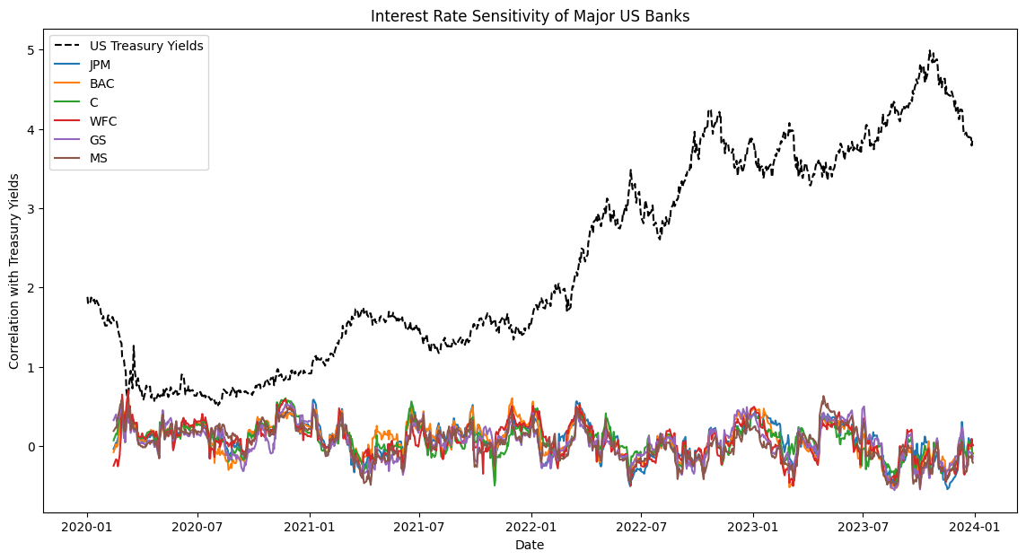**Inference:**

* The interest rate sensitivity graph illustrates how changes in US Treasury yields affect the stock prices of major US banks.
* Banks with higher correlation to Treasury yields, like Wells Fargo (WFC) and Citigroup (C), are more sensitive to interest rate changes.
* Lower correlation for banks like Goldman Sachs (GS) and Morgan Stanley (MS) suggests their stock prices are less influenced by interest rate fluctuations.
* Understanding this sensitivity is essential for investors navigating monetary policy impacts and adjusting investment strategies accordingly.

**Graph 7:** Economic Value Added (EVA) Analysis:

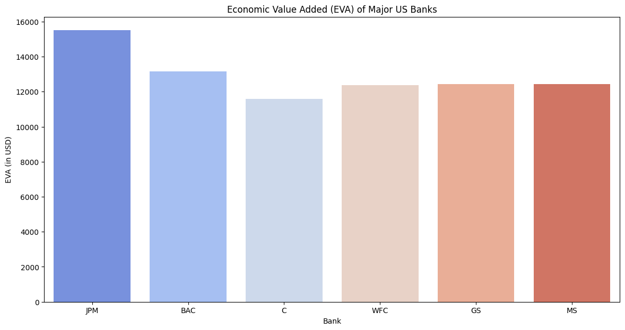**Inference:**

* The EVA graph assesses the economic profit generated by each bank above the cost of capital, providing insights into their financial performance.
* Banks with positive EVA, such as JPMorgan Chase (JPM) and Bank of America (BAC), create value for shareholders beyond their required return on invested capital.
* Negative EVA for banks like Citigroup (C) and Wells Fargo (WFC) may indicate challenges in generating economic profit or inefficient capital allocation.
* EVA is critical for evaluating management effectiveness, strategic investments, and long-term shareholder value creation.

**Graph 8:** Stress Test Simulation:

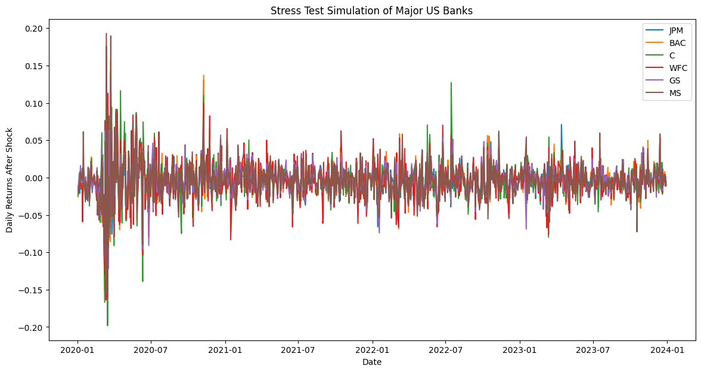**Inference:**

* The stress test simulation graph evaluates how major US banks perform under adverse economic scenarios or shocks to financial markets.
* Banks with more stable post-shock returns, like JPMorgan Chase (JPM), demonstrate robust risk management practices and resilience to economic downturns.
* Higher volatility in simulated returns for banks like Morgan Stanley (MS) and Goldman Sachs (GS) suggests greater sensitivity to market shocks.
* Stress tests are vital for regulators and investors to assess the financial stability, capital adequacy, and risk management capabilities of banks.

**Conclusion:**

In conclusion, cashier's checks, money orders, and safe deposit boxes play pivotal roles in enhancing security, reliability, and convenience within the US banking sector. Cashier's checks and money orders provide secure payment alternatives, ensuring guaranteed funds for transactions ranging from real estate deals to international payments. They mitigate risks associated with personal checks by offering assurance against fraud and insufficient funds. Safe deposit boxes, housed within bank vaults, serve as robust storage solutions for valuable items and sensitive documents, shielding them from theft, fire, and other hazards. They cater to the needs of individuals, families, and businesses seeking to safeguard irreplaceable items and maintain confidentiality. Together, these financial instruments and services exemplify the commitment of banks and credit unions to meet the diverse needs of customers, fostering trust, security, and peace of mind in financial transactions and asset protection.